Preface

This Guide explains how to use Trade Innovation to process the licenses which are required in some countries for the importation and exportation of goods. This includes the functionality needed by the bank’s trade finance department to maintain the license register, as well as how to link licenses to underlying trade transactions.

This Guide assumes that you are familiar with the basic principles of trade finance relating to licenses, and with web browsers.

# Introduction

This chapter provides an overview of Trade Innovation’s licenses functionality.

## Licenses in Trade Innovation

In some countries, licenses are required for trade transactions that involve the import or export of goods, or the purchase of foreign currency. A central authority requires banks to monitor the utilisation against the licenses issued to customers. Returns must be made to the governing authority on a regular basis to show the utilisation.

If a license is required for a transaction it must be applied for before a payment or shipment can be made.

License details can be entered manually in Trade Innovation using the License product, or the details can be received via the customer gateway interface service. A license can be associated with one or more existing transactions; and a single transaction may refer to one or more licenses.

A reservation can be (optionally) made against the license in order to ensure that the transaction amount can be covered by the license at a later date.

Upon receiving a claim or making a foreign currency payment a drawdown is made against the license. The drawdown increases the utilisation recorded against each related license.

Where the full reservation is not used, for example following the final letter of credit payment or on expiry, the unutilised amount can (optionally) be reinstated on the license so that it can be drawn upon by another transaction.

Licenses can also be amended, adjusted, cancelled and booked off.

Once a license has been fully utilised or reached its validity date, you can use an Amend event to mark the license as 'to be cleared' or 'cleared'. Once cleared, the license can be booked off (in other words, no further processing is expected) but any unutilised balance remains on the license for historical purposes. Unlike other Trade Innovation products, a booked off license can be reinstated in order to take advantage of any unutilised balance in the future.

The validation process ensures that the transaction is fully covered by the terms of the associated licenses. Each type of license can be precisely tailored in terms of the parties used for validation and the processing of characteristics required using the system tailoring application.

Using Trade Innovation’s scanning and imaging facilities a copy of the actual license form can be attached to the license.

### Products that Use Licenses

Licenses can be applied to the following products in Trade Innovation:

* Import letters of credit
* Export letters of credit
* Freely negotiable letters of credit
* Import standby letters of credit and guarantees
* Export standby letters of credit and guarantees
* Inward clean and documentary collections
* Outward clean and documentary collections
* Outward clean payment orders (customer payments, bank payments, cheques, and standing orders)
* Finance standalone

## Using Trade Innovation to Process Licenses

The table below list the events covered in this Guide, explaining what each event allows you to do. The table lists the names given to events when Trade Innovation is delivered. Your bank can change these names once the system is installed. Consequently, the names in your version of Trade Innovation may be different from the ones listed here.

There are two names for each event:

* The full name, which is displayed when you choose a new event
* The short name, which is displayed in the Work in Progress pane of the Master Summary window

This Guide uses the full name of each event, as delivered with the system.

In addition to the events listed in the table, you can also use the functionality described in the Common Facilities User Guide – Trade Innovation when processing transactions in Trade Innovation.

|  |  |  |
| --- | --- | --- |
| Full Name | Short Name | What it Does |
| Adjust | Adjust | Allows you to make internal adjustment to the license details (see page 21). |
| Amend | Amend | Allows you to change the details of the license and to manage the license status (see page 20). |
| Cancel | Cancel | Allows you to cancel a license, assuming that there are no underlying transactions that are still live (see page 23). |
| Create | Create | Allows you to register the license details (see page 6). |
| Drawdown | Drawdown | Allows you to record when a payment is made against a license, for reporting purposes (see page 27). |
| Reinstate | Reinstate | Allows you to reinstate the unutilised portion of the license if a reservation had previously been made (see page 29). |
| Reserve | Reserve | Allows you to reserve a license amount when linking to a transaction (see page 15). |

# Before You Begin Using Licenses

This chapter explains what needs to be set up on your system before you can begin using the licenses functionality.

## Configuring Your System to Use Licenses

Before you can start using licenses in Trade Innovation, there are certain things that need to be set up on your system. These include:

* Setting trade finance system options which control whether the license functionality is available on your system and if so, what foreign exchange rate is used for the licenses
* Setting system options that control how licenses are handled by the system
* Setting up product options for the License product itself, and also for the other Trade Innovation products which use licenses
* Defining the different types of licenses that will be available to users of the system. For each license type you can also set default values
* Mapping the license types to the various products and product types within Trade Innovation
* Defining any additional fields that are required to capture license details, other than those supplied with Trade Innovation

These would normally have already been done by the appropriate person within your bank, so this chapter is provided merely to give you an overview. For more detailed information about how to set up Trade Innovation, see System Tailoring User Guide – Trade Innovation.

## Setting the Trade Finance System Options

The following trade finance system options affect the use of licenses in Trade Innovation:

|  |  |
| --- | --- |
| License Required | Implements licensing functionality. |
| License FX Rate Code | Specifies an FX rate code to be used when converting to license currency and base currency. If you leave the rate code blank, the spot rate will be used. (Note that you can only set the FX rate code if the Licenses Required parameter is also set to Yes) |

## Setting the System Options

The following system options affect the use of licenses in Trade Innovation:

|  |  |
| --- | --- |
| LicenseFXRateReadOnly | Allows your bank to prevent the user from changing the foreign exchange rate (used to convert to the license currency equivalent) at license reservation or drawdown. |
| LicenseNumberExtendedValidation | Allows your bank to ascertain the uniqueness of the license record by having Trade Innovation check the license number, branch, registration date and product type. |
| LicenseWarningsOnly | Allows your bank to decide whether error messages should be issued as warning messages instead (so that they can be overridden). |
| SuppressExpiryValidation | Allows your bank to switch off the standard validation process. This checks the expiry date of the transaction against the date up until which the license is valid. |
| SuppressLicenseAtCollectionCreation | Allows your bank to hide the license pane during creation of inward and outward collections. |

## Defining the Product Options

Before you can begin using licenses on your system, you need to have the license product set up on your system. Also, the existing Trade Innovation products will need to be set up to utilise licenses.

Set up the License product, setting the primary customer to 'Principal Party'.

Next, make sure that the various products that will use licenses are set up correctly. In the product options for each such product set the Apply Licenses field as follows:

|  |  |
| --- | --- |
| Yes | Licenses must be applied to transactions that are entered using that product. If a license is not applied and the field is set to Yes, then an error message to that effect is displayed. |
| No | Licenses will not be required for transactions that are entered using that product. The License pane is not then displayed. |
| Optional | It is left to the user to decide whether a license needs to be used or not. If a license is not applied and the field is set to Optional, then a warning message is displayed which may be overridden. |

The Apply Licenses field is only available if the Licenses Required trade finance system option has already been set to Yes.

Even if you set the Apply Licenses field at product level, it may subsequently be overridden for individual product types. For example, you might have set the Import Guarantee product to 'Yes', but you may wish to differentiate between specific guarantee types: for a bank guarantee you might have the license as being optional whereas for a shipping guarantee you might decide that the license must be mandatory.

## Defining Product Types

Before any individual licenses can be entered and applied to transactions in Trade Innovation, you need to have set up different types of license on your system. These are defined using the Product|Product Types menu option. For example, you might wish to set up 'Export license' as one of your license types, so that individual export licenses can subsequently be entered against that license type and applied to export-related transactions.

You can then define default information for each of these types of license. These default values are set in the system tailoring application using the Product|License Definitions Default menu option.

Finally, you also need to check the definitions of all the existing product types that will use licenses. For example, you might want to set up the license as optional for a bank guarantee, but mandatory for a shipping guarantee.

The Licenses Applies field is only available if the Licenses Required trade finance system option has been set to Yes. Set it as follows:

|  |  |
| --- | --- |
| Yes | Licenses must be applied to transactions that are entered using that product. If a license is not applied and the field is set to Yes, then an error message to that effect is displayed. |
| No | Licenses will not be required for transactions that are entered using that product. |
| Optional | It is left to the input clerk to decide whether each particular license needs to be used or not. If a license is not applied and the field is set to Optional, then a warning message is displayed which may be overridden. |

The setting of the License Applies field at product type level will override the setting at the product option level.

## Mapping the Product Types

Once the license types have been defined on your system, you need to specify which products (or product types) the different license types will apply to. This is done by a process of mapping using the Product|License Product Mapping menu option.

The license types you have defined can be mapped to any of the Trade Innovation products that can be used with licenses (and to any product types based on these that may have been defined on your system).

A license type can be mapped to more than one product or product type.

## Defining and Mapping Your Own Fields

You can map up to five of your own fields to the Licenses product.

# Setting Up New Licenses

This chapter describes how to enter new licenses on your system using the Create event.

## Creating a New License in Trade Innovation

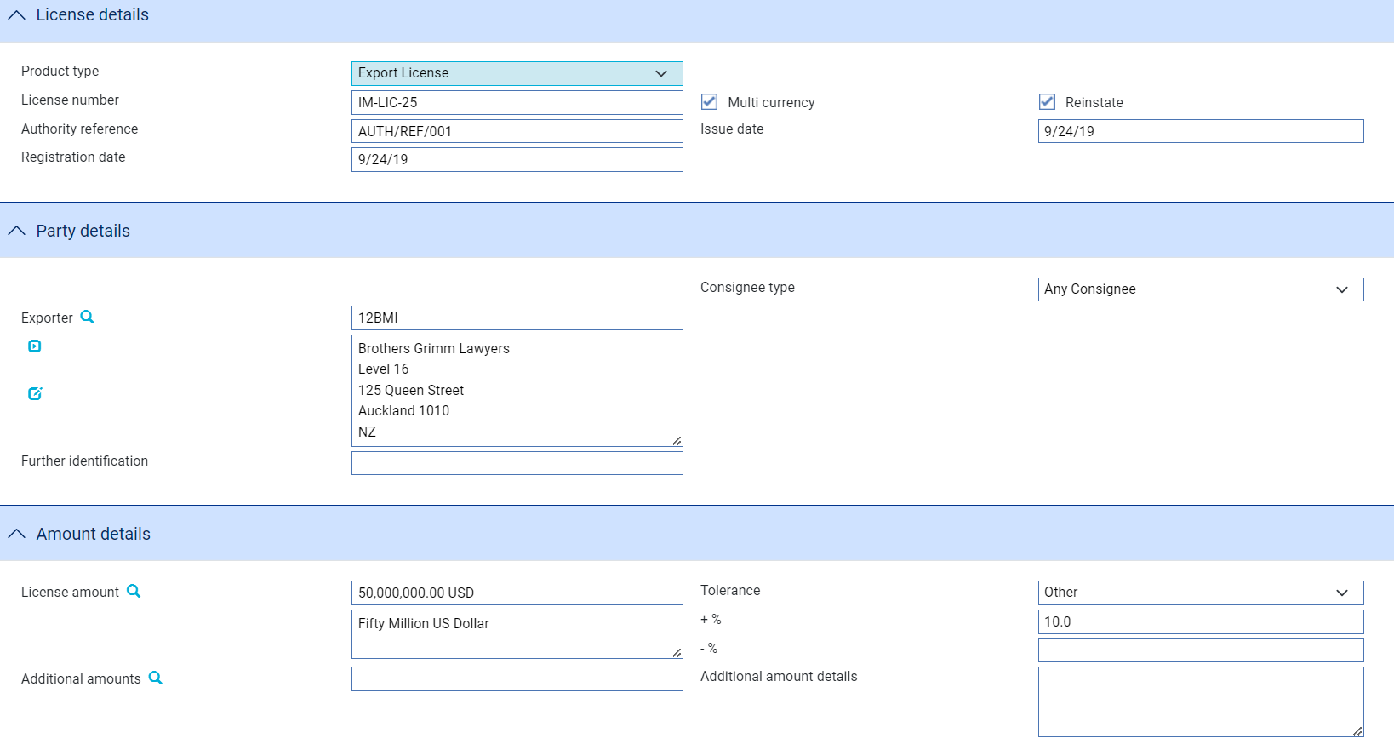

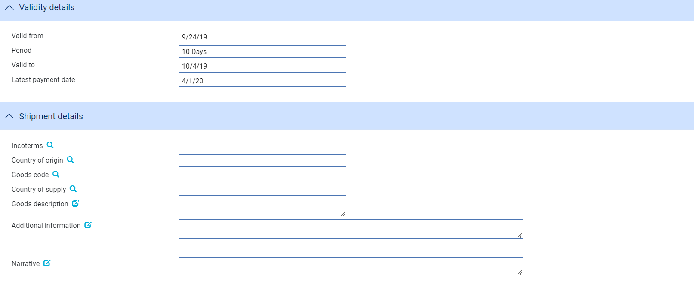

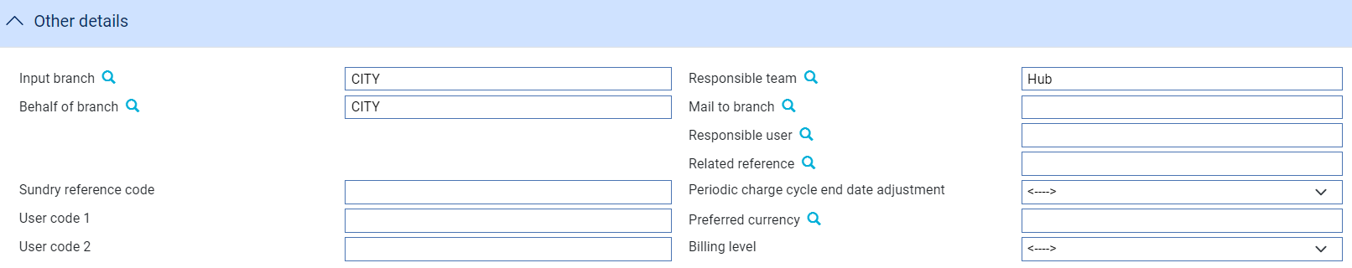

The details of a new license are entered using the Create event. Details can be entered either directly into Trade Innovation, or received via the customer gateway interface service.

When you enter a new license, it must be based on a license type that has previously been defined on your system. To enter a new license manually, in the Masters window, select the Team and Behalf of branch and use the drop-down list in the New Masters pane to select 'License', then press New. Trade Innovation creates the event at either a Log step or Input step. Depending on how your system is configured, panes and fields available in log steps can be tailored for each data capture step. See the *SDK - Systems Interfacing Guide* – Trade Innovation for details.

Initially the event window is displayed with all the fields disabled except for the Product Type. To activate the fields and create a new license, select the appropriate product type and press Refresh.

1. If the fields still remain greyed out when you select a product type, this is because no license default values have been set up for the selected product type. Contact your system administrator for assistance.

Depending on which product type you have selected, there will be minor changes to the layout and contents of the input window:

* The Principal pane will be re-labelled according to the license type settings. For example, for an export license the principal party is the exporter; for an import license, the principal party is the applicant
* The pane that is displayed directly below the Principal pane will also differ according to license type. For example, for an export license the non-principal party is the consignee; for an import license, it is the beneficiary
* The default values for some of the fields will also differ according to license type

The Create event uses the following panes:

* The License Details pane (see page 8)
* The Party Details pane (see page 9)
* The Amount Details pane (see page 9)
* The Validity Details pane (see page 10)
* The Shipment Details pane (see page 11)
* The Other Details pane (see page 11)

### The License Details Pane

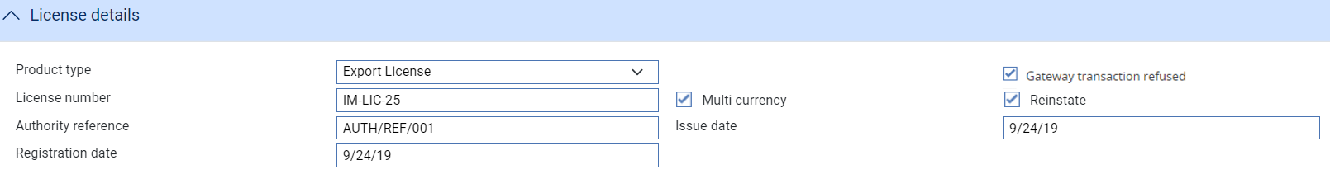

The following table explains what to enter into the fields in the License Details pane:

|  |  |  |
| --- | --- | --- |
|  | Field | What to Enter |
|  | Product Type | Select a type of product from the drop-down list and press Refresh. Until a product has been selected, the other input fields will be read-only. Once the product type has been selected, the defaults for that product type are shown. |
|  | License Number | A unique number that identifies the license, and is issued by the licensing authority. |
|  | Multi-currency | Check this box to allow the license to be utilised by transactions in other currencies. To restrict the use of the license to the currency defined on the license, leave this box empty. |
|  |  | 1. Depending on how the selected product type has been configured, this Multi-currency box may be read-only so that you cannot change the default value. |
|  | Reinstate | This field controls whether any un-utilised balances of licenses on linked transactions should be made available when they are fully paid, cancelled or expired. Check the box to make the unutilised balances available; otherwise leave it empty. |
|  | Authority Reference | The reference number that is assigned to your bank by the licensing authority to signify that your bank is authorised to use the license.  If this field is left blank, the license is treated as temporary and a warning is displayed when you try to process a drawdown. |
|  | Issue date | The date on which the license was first issued. |
|  | Registration Date | The date on which the license was first registered. This field defaults to today's date, but you can change this to any date before today. |
|  | Provisional | Check this box if the event is to be treated as ‘Provisional’, in which case a subsequent version of the event is required before the event can be completed |
|  | Gateway transaction refused | Displayed if the License instruction has been received via the gateway. Check this box if your bank wishes to reject the request to create the License. |

### The Party Details Pane

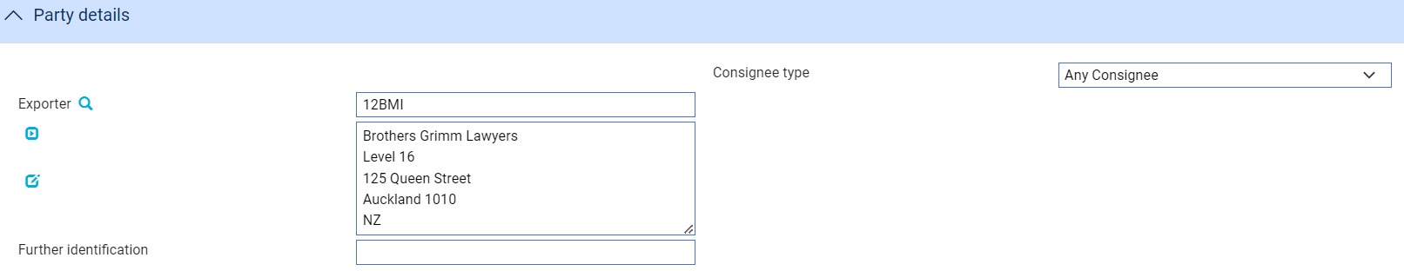

The following table explains what to enter into the fields in the Party Details pane:

|  |  |  |
| --- | --- | --- |
|  | Field | What to Enter |
|  | Exporter/ Applicant | The principal party - for example, for an export license the principal would be the exporter; for an import license, the principal would be the applicant. Your bank decides who the principal is for each type of license. |
|  | Consignee Type/Beneficiary Type | The non-principal party. Select one of the following and then press Refresh:   * Consignee. Use the field displayed when you press Refresh to identify the consignee * Any Consignee in Country. Use the field displayed when you press Refresh to identify the country * Any Consignee, in which case no further clarification is required   The role of the non-principal will differ according to the license type: for an import license this would be the beneficiary, for an export license this would be the consignee, and for an FX license this would be the payee. Your bank decides who the non-principal is for each type of license. |
|  | Further Identification | Any further identification that may be required for the principal party, such as a passport number or certificate of incorporation. |

### The Amount Details Pane

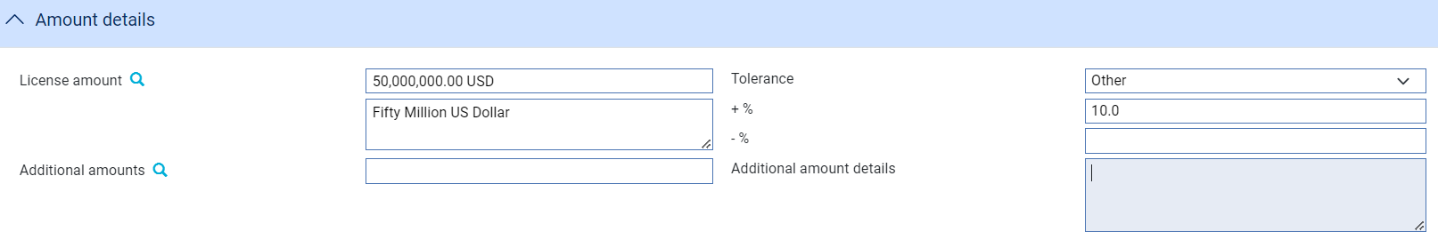

The following table explains what to enter into the fields in the Amount Details pane:

|  |  |  |  |
| --- | --- | --- | --- |
|  | Field | What to Enter | |
|  | Amount | The amount and currency of the transaction. Trade Innovation displays the amount and currency in the language of your system beneath these fields. You can edit this text, if necessary. | |
|  | Tolerance | Specify how the amount is being expressed. Select from one of the following: | |
|  |  | Exact | If the amount is the exact value of the transaction. |
| About | If the amount given in the Amount field is within 10% either way of the expected value of the transaction. |
| Other | If you select this option, use the -% and +% fields to specify as a percentage how much more or less than the final value of the transaction the amount entered is allowed to be. |
| Not Exceeding/ Up To | If the final value of the transaction is expected to be no more than the amount entered, and not less than 95% of the amount entered. |
| Max/Min | If you select this option Trade Innovation displays a + Amount and a - Amount field. Use them to specify as an amount how much more or less than the final value of the transaction the amount entered is allowed to be. |
| Trade Innovation displays the amount and currency in the language of your system beneath these fields. You can edit this text, if necessary. | |
|  | Additional Amounts | Any amounts payable to the beneficiary in addition to the principal amount of the transaction. These might include, for example, local freight charges.  If you enter an amount, it is added to the amount of liability under the transaction. If you use a different currency for the amount, then the amount is converted to the currency of the transaction using the current spot rate. | |
|  | Additional Amount Details | A text description of what any additional amounts are for. | |

### The Validity Details Pane

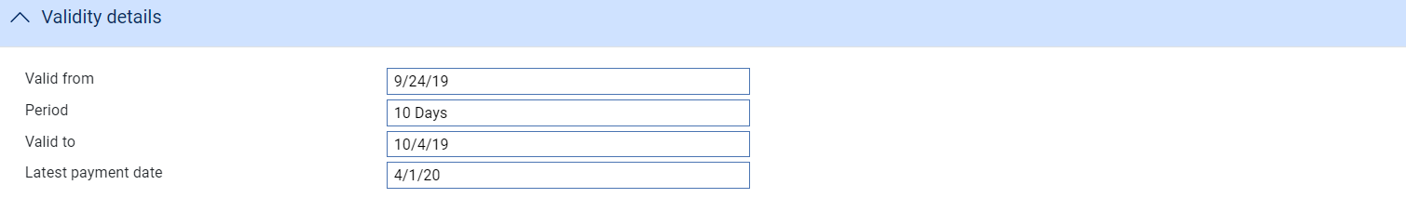

The fields in the Validity Details pane are used to define the period for which the license is valid.

As a minimum, you must enter a Valid From date.

You may also enter details to qualify the period of validity for the license, such as:

* A period after the Valid From date, which is used by Trade Innovation to calculate the Valid To date. This value defaults from the license type but can be changed for an individual license
* A Valid To date, which must be before the latest payment date and may fall on a non-business day. It defaults from the license type, but can be changed for an individual license. The Valid To date is derived from the specified validity period and the Valid From date
* A Latest Payment Date, which determines when a license can be booked off. It defaults to the license validity period that is set on the license defaults. It may not be earlier than the Valid To date, and can fall on a non-business day

1. The Valid From date is validated against the issue dates and start dates of the related transactions, and the Valid To date is validated against the maturity dates or expiry dates of the related transactions.

### The Shipment Details Pane

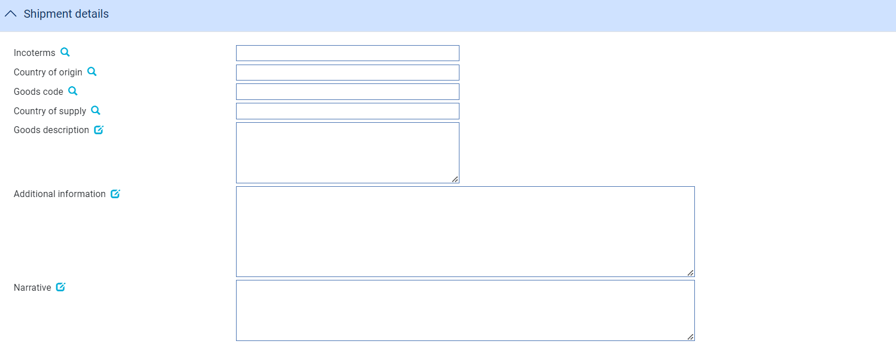

The following table explains what to enter into the fields in the Shipment Details pane:

|  |  |
| --- | --- |
| Field | What to Enter |
| Country of Origin | The country of origin of the goods to be shipped. |
| Incoterms. | Incoterms. |
| Goods Code | The Trade Innovation code for the goods. |
| Goods Description | A description of the goods. |
| Country of Supply | The country of supply. |
| Additional Information | Free format additional information, using the More button if you wish to view more than will fit in the available space. |
| Narrative | Fee format narrative. his narrative text would automatically be included in a SWIFT message if you were to use an MT999 to correspond with another party. |

### The Other Details Pane

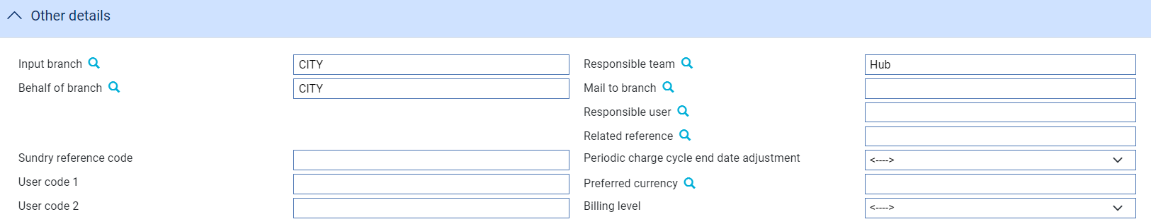

The following table explains what to enter into the fields in the Other Details pane. The pane can include up to five fields, which will have been defined by your bank for accounting and analysis purposes:

| Field | What to Enter |
| --- | --- |
| Input Branch | The input branch for the transaction. The input branch is set from either:   * the accounting branch from the user’s team, or * the transaction branch for user if the user has a default transaction branch or is locked to a specific branch, or * a branch associated with the user where the user can enter transactions for several branches for a team |
| Behalf Of Branch | The behalf of branch for the transaction as entered by the user or set from the incoming SWIFT or gateway message. The behalf of branch determines the parameter sets that are to be used to generate charges, documents, postings, etc. during transaction processing. The branch can be changed to any other branch within the same main banking entity that shares the same parameter sets. |
| Sundry Ref Code /User Code 1/ User Code 2 | You may use these fields to enter values for analysis purposes. Your bank will have devised its own system for using these fields. |
| Responsible Team | The team that has overall responsibility for the master e.g. as the contact to resolve any queries or issues regarding the master and associated events. Trade Innovation defaults the responsible team when creating the transaction as follows:   * Manual – set from team creating the transaction * Gateway – set from the team specified on the incoming message (if present and valid) otherwise to the team to which the transaction is assigned through workflow allocation based on the behalf of branch * SWIFT – set to the team to which the transaction is assigned through workflow allocation based on the behalf of branch   It can be changed, if required, to either the team associated with the primary customer, default team for the product or the user’s current team. |
| Mail To Branch | The mail to branch can be set to any branch within the main banking entity of the behalf of branch. |
| Responsible User | A user that has responsibility for the master e.g. as the contact to resolve any queries or issues regarding the master and associated events. This can be any user assigned to the responsible team. |
| Related Reference | You can specify any other transaction to which this letter of credit is related. This may already have been done when the master record was created. You can use the browser to select from possible references to include. |
| Preferred Currency | The currency in which the principal party's charges will be collected. If you leave this field blank, Trade Innovation uses the customer charge currency defined on the product options. |
| Billing Level | Select whether charges for this license should be billed at customer level, transaction level or product level. |

## Validation

Trade Innovation performs validation once you have completed an Input step, depending on how your system has been set up. As a minimum, the following apply.

Your bank will have defined whether a license is required or is optional for each product or product type. If the selected product or product type indicates that a license is required, then you must have linked at least one valid license to the transaction. You cannot link a license if the selected product or product type indicates that a license is not required. Your bank will also have defined whether multiple licenses are allowed for each product and product type.

The amount attributed to the license must be less than or equal to the license available amount (including any reservations).

For cumulative revolving letters of credit, the license amount must be sufficient to cover the maximum amount available for the letter of credit (in other words, the letter of credit amount multiplied by the maximum number of the revolving cycle).

The total amount attributed across all licenses (in other words, the total allocated amount) must not exceed the transaction amount. In the case of letters of credit, standbys and guarantees this also includes the amount tolerance. If the amount of the transaction (plus tolerance, where applicable) is not fully attributed to one or more licenses, a warning is displayed.

The transaction and license currency must match unless the license has specifically been set to allow multiple currencies.

Your bank may have defined the party roles to be used as the principal and non principal for each license type and also for each product type and, if so, these must match. For example, your bank might have nominated the principal party of the import license to be validated against the applicant party of the import letter of credit; the principal party of the export license (in other words, the exporter’s name) may have been nominated to be validated against the beneficiary of the export letter of credit.

The allocated amount of the shipment will be validated against that on the license. For shipment with non FOB incoterms, you can specify the transaction amount that represents the FOB value for validation.

Your bank has the option to validate single goods codes against the HS code on the license.

The transaction issue date or start date must not be before the license issue date.

Shipment date, if present, must be between the license valid from and valid to date.

The transaction expiry or maturity must not be after the license Valid To date.

Once validation has been completed successfully, process the Review and/or Authorisation steps according to how your system has been set up, and then the event is then released in the usual way.

## The Master Summary Window for Licenses

Once you have created a license, Trade Innovation will display the basic details of that license using the Master Summary window.

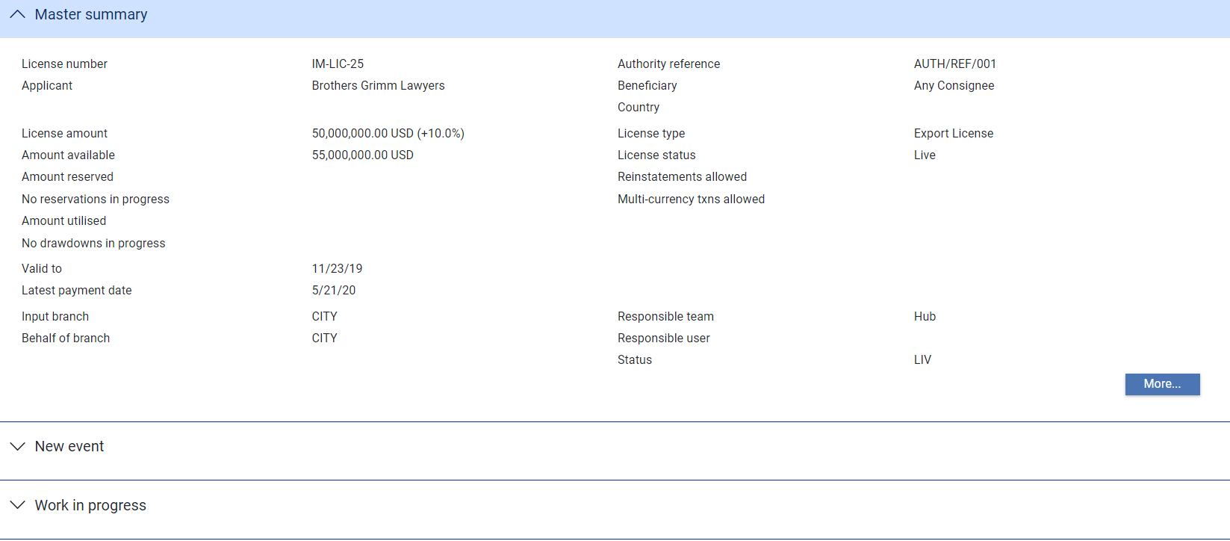

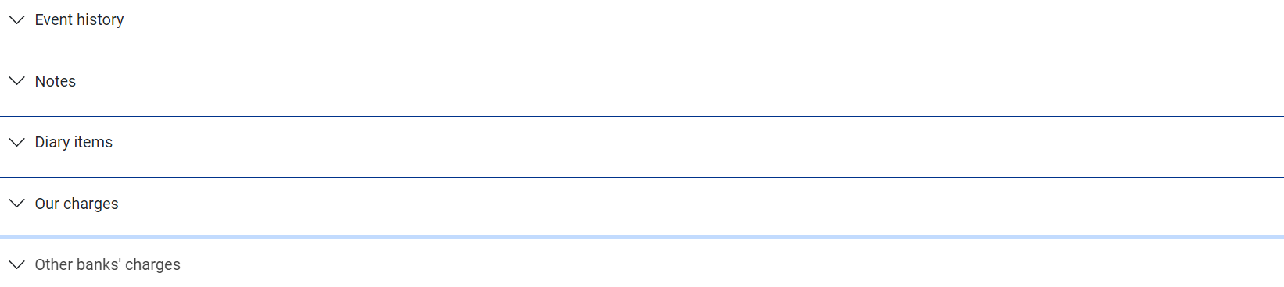

For more information on how the various panes and buttons in this window work see the Common Facilities User Guide – Trade Innovation.

# Linking a License to a Transaction

This chapter covers the linking of licenses to transactions.

## Linking a License to a Transaction in Trade Innovation

Once a license has been created and released, transactions can be associated with the license. The license may be linked to a transaction at various times in the product life-cycle. This may be at the time that a transaction is initiated, or when the transaction is subsequently amended or adjusted. For collection orders, licenses can be linked at the time of payment (instead of at the creation of the collection order) if the SuppressLicenseAtCollectionCreation system option is set. Each of the Trade Innovation products that can have licenses attached can be linked to one or more existing licenses and, likewise, each license can be linked to one or more of transactions.

Linking a license to a transaction involves allocating the transaction amount to the license so that drawdowns may subsequently be made against this allocation. It may also involve reserving a corresponding amount on the license, and some products may involve drawdowns at the time of linking.

Linking a license to a transaction may involve reserving the amount of the transaction against the license, in which case a Reserve event is created as a subsidiary event against the license once the event linking the transaction and license is released. Depending on how your system is configured, it may require manual intervention, such as review and/or authorisation, before the Reserve event is released.

### The Licenses Pane

Licenses are linked to transactions using either the Licenses pane, or a Licenses button.

Where the Licenses pane is used it appears as the last pane in the window.

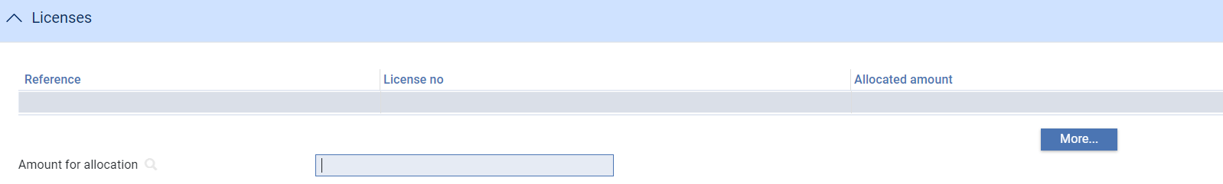

The following table shows the events in which the Licenses pane or button appears for each trade finance product:

| Product | Event |
| --- | --- |
| Letters of Credit | Issue  Amend  Adjust  Advise  Claims Received Outstanding Claims  Docs Presented  Outstanding Presentation  Cancel  Expire |
| Freely Negotiable LCs | Free Negotiation |
| Standbys and Guarantees | Issue  Advise  Adjust  Amend  Claim Received  Docs Presented  Outstanding Claim  Outstanding Presentations  Renewal  Reduction  Increase  Cancel  Expiry |
| Collection Orders | Create  Amend  Adjust  Payment  Expire |
| Clean Payments | Create |
| Standing Orders | Create |
| Financing | Create  Adjust  Amend |

## Linking a License to a Transaction

When you are entering details of a transaction, if the product or product type with which you are working has been configured so that a license is mandatory or optional, the Licenses pane is present. It lists any licenses that have already been linked to that transaction.



The Amount for Allocation field shows the full amount that needs to be covered by the license.

For import and export letters of credit, standbys and guarantees the allocated amount defaults to the maximum amount - in other words, the amount of the letter of credit/standby/guarantee, plus any tolerance that has been set.

For revolving letters of credit, the allocated amount defaults to the maximum letter of credit amount plus tolerance, multiplied by the number of revolutions.

For collection orders, the allocated amount defaults to the collection order amount.

For clean payments, the allocated amount defaults to the payment amount.

For standalone financing transactions, the allocated amount defaults to the amount of the loan.

The More button opens the window used to link licenses to the transaction, and for making reservations and drawdowns against the license.

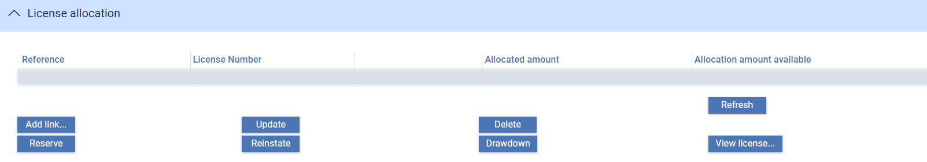

To link a license to the transaction, press the Add Link button. This opens the License Browser, which you can use to select from all the live licenses that are currently on the system.

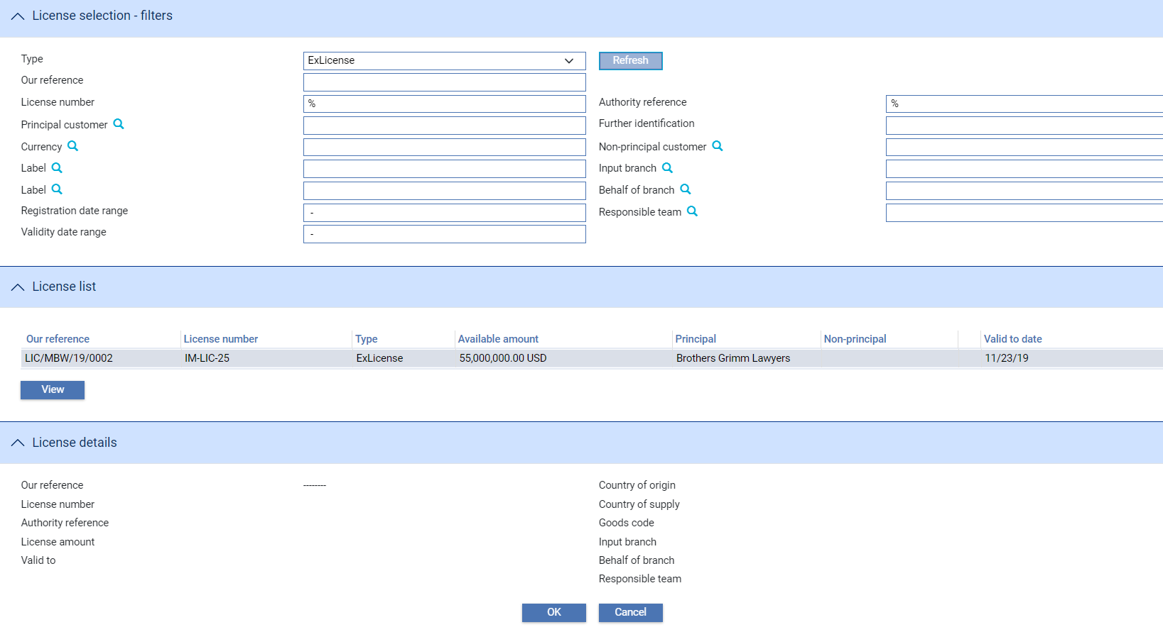

When the License browser opens, it has its filters pre-set to select all licenses where:

* The status of the master is live
* The status of the license is live
* The license matches the product type (provided that you only have one type of license associated with the product)

In addition, if a principal and non-principal party have been entered on the transaction, the appropriate filters on the browser are pre-set to those parties (again - provided that you only have one type of license associated with the product).

Once you have selected a license from the browser, it is linked to the transaction and the Licenses window will be updated. This means that the transaction amount has been allocated to the license, and drawdowns may now be made against that amount when payment is processed.

If the transaction amount changes during the life of the contract then, depending on circumstances, you may need to either:

* Change the existing allocation and reservation amounts, or
* Make additional reservations against the allocation, or
* Link additional licenses to cover an increased contract value, or
* Reinstate part of the license amount

Using the buttons on the window, you can manage the license allocations and reservations as listed below. Note that one or more buttons may be disabled, depending on the type of event.

|  |  |
| --- | --- |
| Button | What it Does |
| Add Link | If the default for that license type is set to allow multiple licenses per transaction, then you can continue to add other links from this window. For example, you might wish to split the payment across several licenses.  When you add a link, it will default to the currently unallocated amount (if this is smaller than the license amount available); otherwise it defaults to the license amount available. The amount cannot exceed the current available amount on the license. |
| License | To review the details of the selected license, click **License**. |
| Delete | You can delete an allocated license or a reservation by selecting them on this window and clicking **Delete**. |
| Update | The allocated amount of each license may be increased or decreased depending on the type of amendment, in line with increase or decrease of the transaction value. You can amend the allocated amount by selecting the license and clicking on the Update button. The Link License window appears, where you can review the license details and amend the allocated amount.  The Allocation Amount field allows you to override the amount that has been automatically selected by the system. This might be used, for example, to accommodate any differences between the incoterms of the license and the incoterms of the letter of credit. The allocated amount must not exceed the transaction amount. |
| Reserve | You can add a manual reservation to a license allocation that is not yet reserved. See the next section. |
| Draw Down | The Draw Down button is not activated until payment of the transaction. It can then be used to manage the drawdown of funds against the license amount for clean payments, financing transactions and freely negotiable letters of credit.   1. For clean payment, financing transactions and freely negotiable letters of credit, drawdown is used instead of reserve as the license is immediately drawn down to reflect the payment. Reserve is never available for these products. |
| Reinstate | The Reinstate button is not active until after the Create event is completed. Thereafter it can be used to reinstate any part of the license amount that is not used in payment of the transaction - for example, during final payment of a transaction, or at expiry or cancellation of that transaction. |

### Reservations

Reservations may be made manually or automatically, depending on the set-up in the License product mapping. If the reservation has been made automatically, Trade Innovation lists both the license allocations and the corresponding reservations that have been made for that transaction. However, note that for some products (such as financing transactions, freely negotiable letters of credit, or clean payments) you get a drawdown instead.

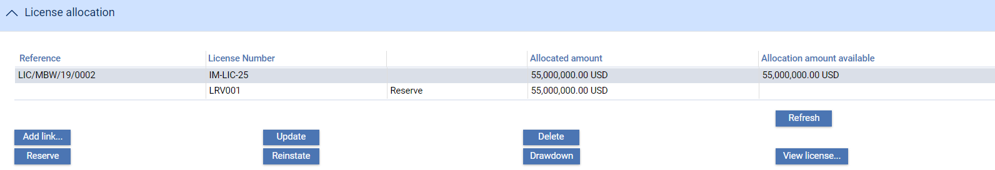

If the reservation has not been made automatically, only the license allocation is displayed. You can make the reservation manually by selecting a license allocation and pressing the Reserve button.

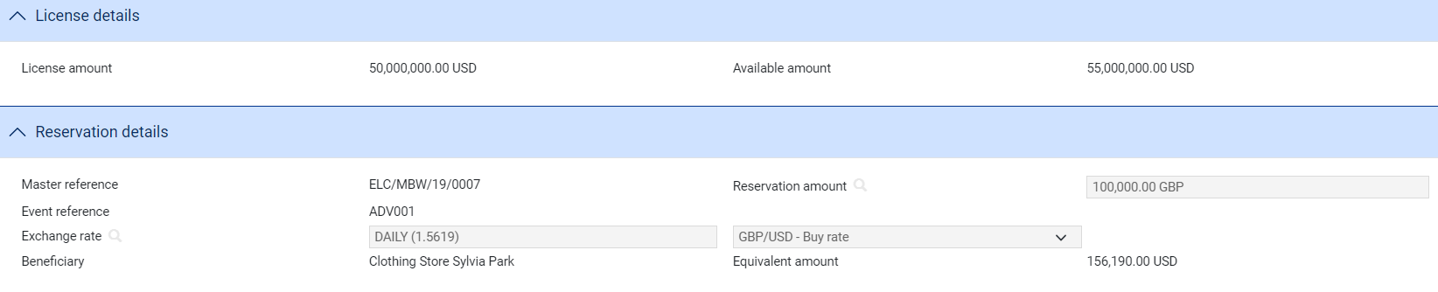

In the window that opens you can enter a reservation amount and an exchange rate. These will default respectively to the amount of the corresponding allocation and the rate that has been defined as the default for licenses, but you can amend them if necessary. (The LicenseFXRatesReadOnly system option controls whether or not you can change the exchange rate on this window.)

The amount that is reserved would normally be the same as the allocated amount on the transaction. It cannot be more than the available amount on the license, plus any outstanding reservations if any.

By default, the whole of the allocation amount will be allocated to the license that you have selected, assuming that there is sufficient amount available on the license. You can manually spread the transaction amount across more than one license by using the Update button, which is described in the table below. Where the available amount on the license is insufficient, Trade Innovation will only allocate the amount that is available, and you must select another license to cover the shortfall.

The Reserve event can be viewed from within the Work In Progress pane. It shows the same details as in the Reservation Details pane.

# Making Changes to a License

This chapter describes the events that allow you to change a license that has already been created and released.

## Making Changes to a License in Trade Innovation

Trade Innovation provides two events that allow you to make changes to the details of a license once it has been entered on the system:

|  |  |
| --- | --- |
| Amend | used to manage the license status or to change any other details that have been entered at license input (see page 20). |
| Adjust | designed for internal bank adjustments only, and enables you to make manual changes to any of the license details (see page 21). |

Amendments to a license would normally be used to manage the license status. For example, you may amend the license status from 'Live/To be Cleared' to 'Cleared'. An Amend event can be used to change any of the fields on the license, however. If you make an amendment to a license, note that:

* It is not possible to amend the license currency (as this will affect all previous drawdowns) or the product type
* The new license amount must be more than the sum of the reserved amount and the utilised amount

## Amending a License

To amend a license, in the Master Summary window select 'Amend' from the Create New Event drop-down list. Trade Innovation opens the event at either a Log step or Input step. Depending on how your system is configured, panes and fields available in log steps can be tailored for each data capture step. See the *SDK - Systems Interfacing Guide* – Trade Innovation for details.

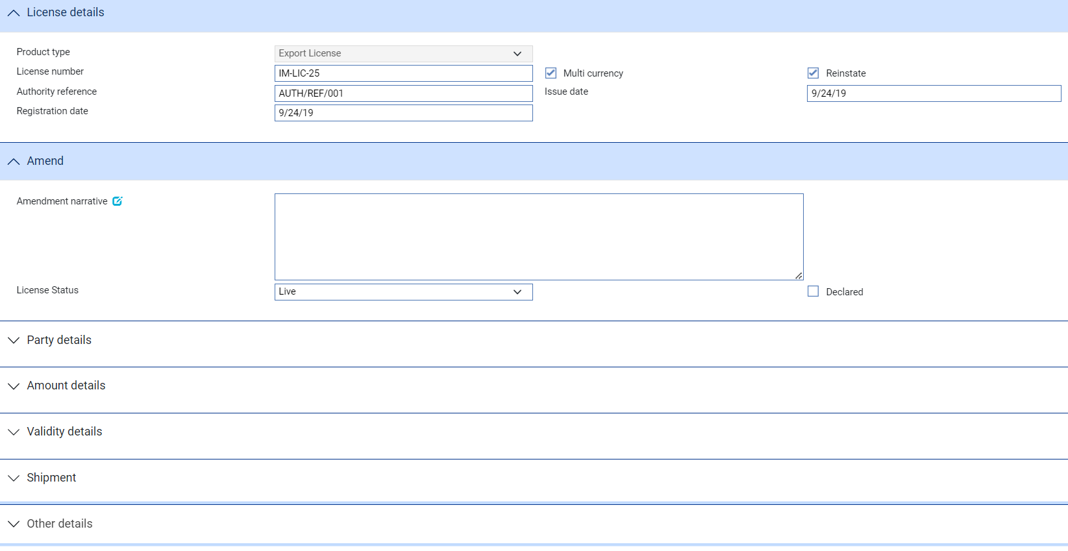

The fields are identical to those used when creating the license, with some additional fields described in the table below:

|  |  |
| --- | --- |
| Name | Description/Purpose |
| Amendment Narrative | Any information regarding the amendment. This field is included in MT999 SWIFT messages and may also be included in documents. |
| License Status | You can use this field to change the license's status to 'Live', 'To Be Cleared', or 'Cleared'.  If the license status is changed to 'Cleared', then the system will automatically diarise a Book Off event if one does not already exist in the diary.   1. You cannot book off a license unless the status has been set to 'Cleared'. |
| Declared | Check this box if you want the system to verify that the cleared license file has been transmitted to the authorities. This is only required for reporting purposes, and defaults to No. |

You can use the Changes (see page 22) button to view details of any changes that have been made during the current event.

## Adjusting a License

This event is designed for internal bank adjustments only, and enables you to make manual changes to any of the license details. For example you might use it to manually adjust the balances on the license in order to reinstate a balance if an outward clean payment was later rejected.

To make an adjustment to a license, in the Master Summary window select 'Adjust' from the Create New Event drop-down list. Trade Innovation opens the event at either a Log step or Input step. Depending on how your system is configured, panes and fields available in log steps can be tailored for each data capture step. See the *SDK - Systems Interfacing Guide* – Trade Innovation for details.

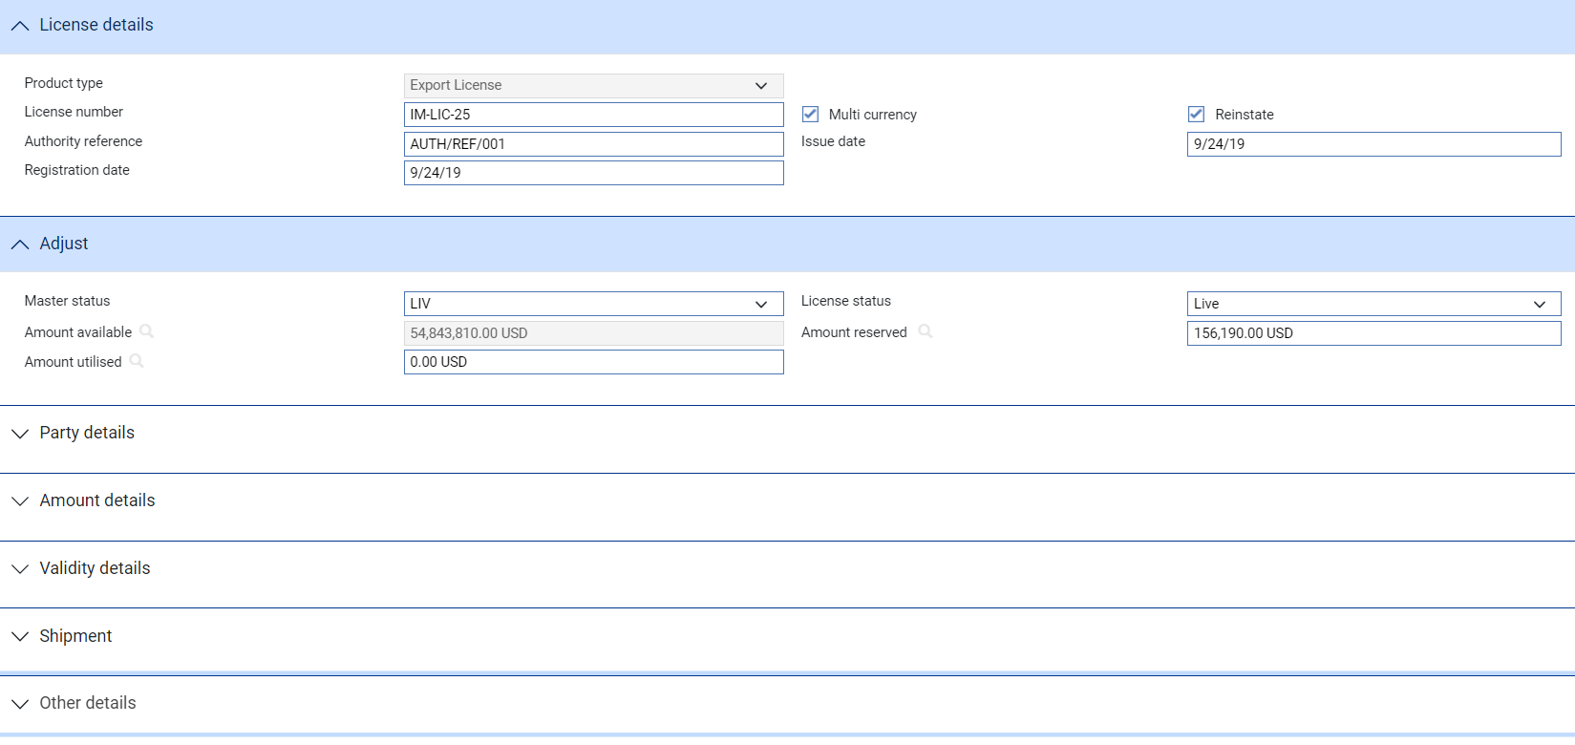

The fields are identical to those used when creating the license, with some additional fields described in the table below.

You can use the Changes (see page 22) button to view details of any changes that have been made during the current event.

| Field | What to Enter |
| --- | --- |
| Master Status | You can change the status of the license's master record from 'Booked Off' (BKF) to Live' (LIV), so that your bank can use the available balance. |
| License Status | The status of the license. |
| Amount Available | The amount currently available on the license. |
| Amount Reserved | The amount currently reserved against the license. |
| Amount Utilised | The amount of the license already utilised. |

## Displaying Changes

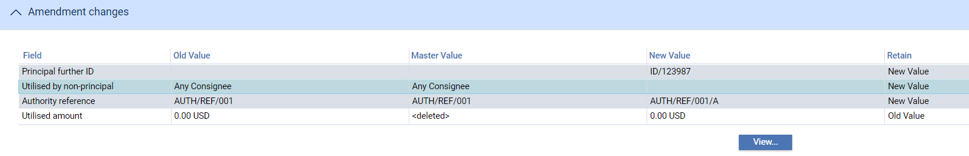

When making amendments or adjustments to a transaction the Changes button allows you - and reviewers - to list those fields that have changed within the event. It opens a window that lists those fields whose value has changed and shows for each the value before the current event and the new value resulting from the event.

For free-format narrative fields, your bank can configure Trade Innovation so that it shows either the entire content of the field in the New Value column, or just a certain number of lines (defined by the system option ViewChangesLineCount) followed by the text:

>>> plus n more lines. 'View' for details.

where n is the number of additional lines not displayed.

Selecting that entry in the list and pressing the View button displays the entire content of the field.

This window is displayed automatically when the event is opened for review or authorisation.

1. If you work with this window open, use the Refresh button to update the display to show any changes made since you opened the window.

For fields where the value may not fit in the space available in this window (narrative fields, for example), you can select the field and press the View button to see complete details.

# Cancelling a License

This chapter explains how to cancel a license.

## Cancelling a License in Trade Innovation

A license can be cancelled at any time after the release of the event that created it and book-off. However, you cannot cancel a license that is still linked to live transaction.

To cancel a license, in the Master Summary window select 'Cancel' from the Create New Event drop-down list. Trade Innovation opens the event at either a Log step or Input step. Depending on how your system is configured, panes and fields available in log steps can be tailored for each data capture step. See the *SDK - Systems Interfacing Guide* – Trade Innovation for details.

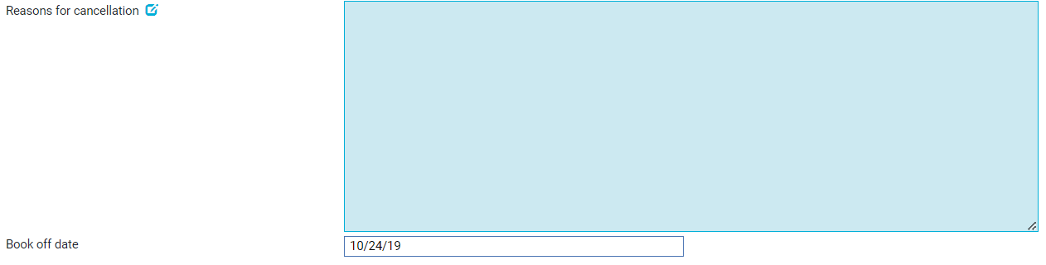

Use the Reasons for Cancellation field to enter a reason for the cancellation, and the Book Off date field to amend the license's book-off date. See the Common Facilities User Guide – Trade Innovation for more information on how licenses are booked off.

# Processing Licensed Transactions

This chapter describes the events that may occur in the life of a transaction that has one or more licenses attached to it, and which will impact the processing of the licenses.

## Licenses and Subsidiary Events

The processing of transactions that have licenses linked to them results in the creation of subsidiary events against the linked license(s).

For example, if an import letter of credit is expired with part of the reserved amount unutilised at the time of final payment, then a Reinstate event on the license will be initiated as a subsidiary event - (assuming that relevant options have been set).

Typically there are two processing models. The first, shown below, involves three steps and is used in letters of credit, standbys and guarantees, and optionally for collections.

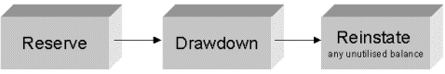

The second processing model, shown below, involves only a single step and is used for financing, clean payments, freely negotiable letters of credit, and optionally for collections.

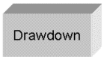

The three processing steps are handled in events within the license. However, they are always initiated as subsidiary events from the related transaction that is being processed. Each event can have its own charges, postings and documents, and these can all be reviewed along with the items in the main processing event. For further information see the Common Facilities User Guide – Trade Innovation.

### Events That Update a License

The following table specifies which events for each product will affect the utilisation and reservation amount on the license. This may either increase the utilisation (for example, as a result of an increase in the letter of credit amount) or decrease it (for example, to restore any unutilised letter of credit balance to the license on the final payment or expiry):

| Product | Event | Reserve | Draw | Reinstate |
| --- | --- | --- | --- | --- |
| Letters of Credit | Issue | For LC amount |  |  |
|  | Amend | If increase |  | If decrease |
|  | Adjust | If increase |  | If decrease |
|  | Expire |  |  | For unutilised amount |
|  | Claim Received/ Docs Presented |  | For part payment | If final payment |
|  | Outstanding Claim/ Outstanding Presentation |  | For part payment | If final payment |
|  | Cancel |  |  | For unutilised amount |
| Freely Negotiable LC | Free Negotiation |  | For part payment |  |
| Standbys and Guarantees | Issue | For standby amount |  |  |
|  | Amend | If increase |  | If decrease |
|  | Adjust | If increase |  | If decrease |
|  | Expire |  |  | For unutilised amount |
|  | Claim Received/ Outstanding Presentation |  | For part payment | If final payment |
|  | Outstanding Claim/ Docs Presented |  | For part payment | If final payment |
|  | Cancel |  |  | For unutilised amount |
|  | Reduction/ Increase | If increase |  | If decrease |
|  | Renew | For LC amount (if renew at original value) |  |  |
| Collections | Create (optional) | For collection amount |  |  |
|  | Amend (optional) | If increase |  | If decrease |
|  | Adjust (optional) | If increase |  | If decrease |
|  | Pay |  | For part payment |  |
|  | Expire |  |  | For unutilised amount |
| Clean Payments | Create |  | For pay amount |  |
| Standing Orders | Standing Order |  | For pay amount |  |
| Financing | Create |  | For loan amount |  |
|  | Amend/Adjust |  | For increase amount |  |

## Making Amendments

When the amount or currency of a transaction is amended, the amount allocated to any linked license (and its reservation) will also need to be increased or decreased to reflect the change to the transaction value. This would be as a subsidiary event to the amendment of the parent transaction. It may also be necessary to initiate a further drawdown.

To update the allocated amounts and reservations on the license, open an Amend event for the parent transaction and then click on the More button in the Licenses pane. The Licenses window is displayed and lists any allocations and reservations that are currently made against the transaction.

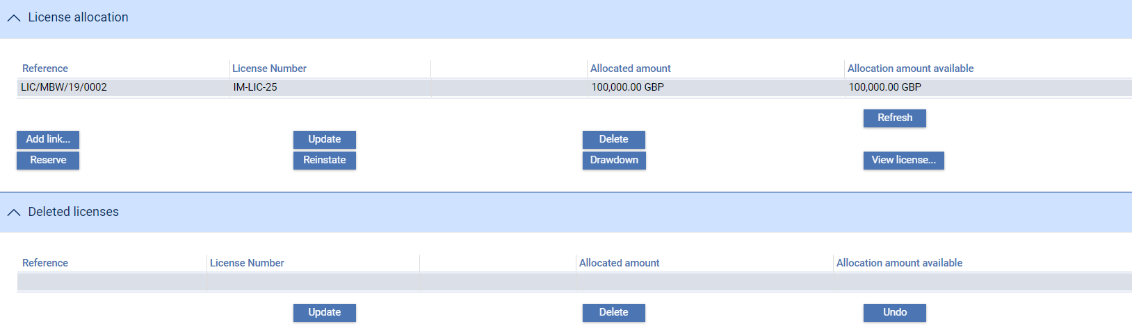

Where there is only a single linked license, the system will have automatically created the necessary reservation, drawdown or reinstatement (if the amount is decreased). Where there is more than one linked license, you must manually enter the appropriate allocations, reservations, drawdowns or reinstatements - the relevant buttons are enabled as appropriate. The buttons on this window are as follows:

|  |  |
| --- | --- |
| Button | What it Does |
| Add Link | Allows you to associate one or more new licenses with the parent transaction if there is insufficient available amount on the existing license to cover an increase in the transaction amount (see page 15). |
| Licenses | Allows you to see details of the selected license. |
| Delete | Allows you to remove an existing link to a license. Once you have deleted it, the details of the deleted link are listed in the Deleted Licenses pane. From here, you can restore the deleted allocation (by selecting it and clicking on the Undo button) or review its details (by selecting it and clicking on the View button). You can also remove the reinstatement from the pane (by selecting it and clicking Delete) or change the reinstatement amount or exchange rate (by selecting the reinstatement and clicking on the Update button). |
| Update | Allows you to change the allocated amount. |
|  | |
|  | You can override the amount that has been automatically selected by your system. This might be used, for example, to accommodate any differences between the incoterms of the license and the incoterms of the letter of credit. The allocated amount must not exceed the transaction amount.   1. When you are amending a license allocation, all the fields on the Link License window are read only with the exception of the Amount to allocate field. |
| Reserve | Allows you to add manual reservations for a transaction increase that is not yet allocated. Click on the Reserve button and the License Reserve window is displayed. Here you can set the amount of the reservation as well as the exchange rate to be used. |
| Reinstate | Allows you to reinstate any part of the license amount as a result of a decrease in the transaction value. |
| Draw Down | Allows you to make a drawdown against a license if the transaction amount has increased - see the next section (see page 27). You can also double click on a drawdown in the License window to make a drawdown. |

### Drawdowns

When a payment event is used to settle a transaction that has a license applied to it, funds will need to be drawn down against the license as part of the payment. This is done using a Drawdown event for the license as a subsidiary event to the payment event. Licenses can be drawn down both at final payment and at part payment. A drawdown may also be used for financing transactions, and for outward clean payments - either when they are created or when financing is amended.

1. For specific information about the payment events for the transaction, please refer to the appropriate product-specific user guide. For example, if your transaction is an import letter of credit, see the Import Letters of Credit User Guide – Trade Innovation for details of the Claims Received event.

A separate Drawdown event is required for each part payment that is to be made in the course of a payment event, and each part payment can have multiple drawdowns if it has links to multiple licenses. Drawdowns can either be made immediately if is a sight payment, or can occur on the maturity date for acceptance and deferred payments. Depending on the payment action you choose, the system will determine if an automatic drawdown is required. You can manually override this to add or delete drawdowns, or to alter the defaulted amount or value date.

In the simplest case, the transaction being settled would be linked only to a single license, and settled as a single payment - which is therefore the final payment. However, sometimes it is more complicated. For example, a claim against a letter of credit might involve more than one type of payment - a sight payment for 40% and the other 60% payable by 60 days acceptance.

Possible payment scenarios include:

* A single (and therefore final) payment with a single license allocation
* A single (and therefore final) payment, but with multiple licenses allocated to it
* More than one part payment for the transaction, all covered by a single license
* More than one part payment for the transaction, each one with its own license
* More than one part payment for a transaction, at least one of which has multiple license allocations

The Drawdown event may take place automatically, or if there is more than one payment involved in the event then you will need to specify the distribution of funds by means of manual Drawdown events. Click on the Licenses button in the Associated Payment Details pane.

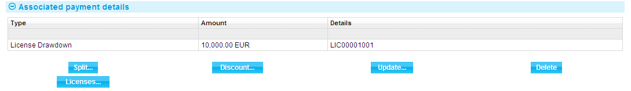

In the window displayed you can link the transaction master to additional licenses, amend existing links, or delete any links that are no longer required.

Selecting the drawdown either here or in the Associated Payment Details pane and pressing the Update button displays details of the drawdown.

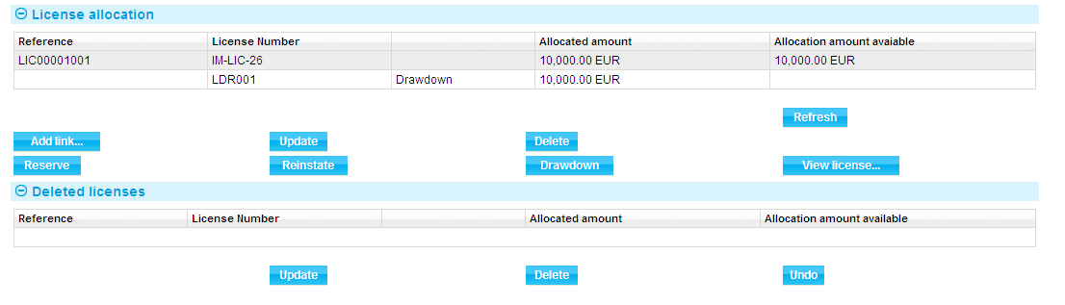

You can also drawdown funds against a license by clicking on the Drawdown button. This button displays a window in which you can confirm the details and process the drawdown.

By default, the drawdown amount is set to the same as the payment amount but you can amend the payment value date, drawdown amount or exchange rate for the drawdown. If the payment/drawdown currency is different from that on the license, the drawdown amount will be converted into the license currency and amount for drawdown.

Note that the available amount shown includes any completed drawdowns and reservations, but not drawdowns in progress or reservations in progress. The validation does, however, take these into account.

The drawdown must be within the remaining allocation amount or the license amount, plus any tolerance that has been entered. If the claim is overdrawn, and assuming that the license has not been set up to permit overdrawal, then an error message will be displayed. (Your bank will have set up the system parameters to control the way that overdrawn licenses, tolerance limits and multiple licenses are handled on your system.)

If the license amount has previously been reserved, then at drawdown the reserved amount will be reduced by the drawdown amount, and the utilised amount will be increased by the same amount. However, if there were no reservations, then at drawdown the utilised amount will be increased by the drawdown amount and the available amount will be reduced by the drawdown amount. In the first case, the available amount is not changed.

The total of all the drawdowns must not exceed the amount available on the license. If the drawdown amount does exceed the license amount available, then a warning or error message (depending on how your system has been set up) is displayed. If a drawdown reduces the available balance on the license to zero or less, then the license status will automatically be changed from ‘Live’ to ‘To be cleared’.

Drawdown details also appear in the payment table, along with financing details and disbursements for transferable letters of credit, and assignment of proceeds. You can double-click on the license details in the payment table to update details too.

## Reinstating Unutilised Amounts

The Reinstate event enables any reserved amount from the transaction that is unutilised at the time of final payment, expiry or cancellation to be reinstated on the license, providing that a reservation was made earlier and that the license specifies that reinstatement is required.

Reinstatements can occur due to:

* Final payment
* Expiry
* Cancellation
* Decrease in transaction value

The reinstated amount is automatically made available for drawing by another transaction. Where more than one license is related to the transaction, the system assigns the outstanding amounts according to the original allocations from each of the licenses.

Reinstatement may have been set up on the license default as being automatic, or it may have been set on the individual license during input. Assuming that reinstatement is enabled, then the Reinstate event is automatically created when a licensed transaction is expired.

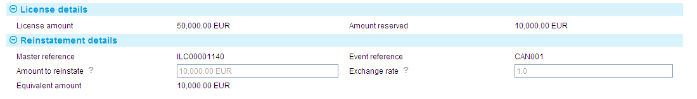

Where there is only one license attached, the expiry of the transaction will release both the expiry event and the reinstatement automatically during end of day, providing there are no errors or warnings. However the Reinstate event cannot be automatically released, nor can its associated event (for example Expiry), if more than one license is attached. In this case, you must specify how much of the unutilised reserved balance must be reinstated for each license.

## Book-off and Deletion

Once a transaction has been expired, Trade Innovation calculates the book-off date from the book-off period (using the product option settings for the license). Assuming your system has been set up to do so, you can reinstate booked off licenses.

Once the transaction details have been archived then the system sets the retention period using the product option settings for the product for the retention period. After the retention date the transaction details are deleted from the system.

Note that Trade Innovation does not allow the transaction details to be deleted if any of the related licenses have not got a retention date set, or if their retention date is later than that of the transaction.

See the Common Facilities User Guide – Trade Innovation for more information on how transactions are booked off.

# Appendix Worked Examples

This appendix provides examples to illustrate how the balances of a license would increase or decrease in line with reservations, drawings and reinstatements. The examples show different scenarios, listing the changes in the balances as each step is completed.

The figure shown on the license master summary for the available amount is the license amount plus tolerance, less any drawdowns. In other words, it does not include any reservation amounts. The reservations and drawdowns in progress are, however, taken into account for validation purposes. In these examples the available amount is shown less any reservations made.

In the first scenario, reservations are made against licenses:

|  |  |  |  |  |
| --- | --- | --- | --- | --- |
| Step | | Available | Reserved | Utilised |
| A license is created for US$200,000 plus a 10% tolerance. | | 220,000 | 0 | 0 |
| 1 | LC 50,000:  reservation made. | 170,000 | 50,000 | 0 |
| 2 | Collection payment for 80,000: drawdown made but no reservation. | 90,000 | 50,000 | 80,000 |
| 3 | Collection payment for 100,000:  drawdown is made but no reservation. A warning is displayed as this plus reserved value exceeds license amount. | 0 | 50,000 | 180,000 |
| 4 | LC claim for 50,000:  drawdown is made and the reservation cleared. A warning is displayed as this exceeds the available amount. | 0 | 0 | 230,000 |

In the second scenario, no reservations are made against licenses:

|  |  |  |  |  |
| --- | --- | --- | --- | --- |
| Step | | Available | Reserved | Utilised |
| A license is created for US$200,000 plus a 10% tolerance. | | 220,000 | 0 | 0 |
| 1 | LC for 50,000:  no reservation and no drawdown. | 220,000 | 0 | 0 |
| 2 | Collection payment for 80,000:  drawdown is made but no reservation. | 140,000 | 0 | 80,000 |
| 3 | Collection payment for 100,000:  drawdown is made but no reservation. | 40,000 | 0 | 180,000 |
| 4 | LC claim for 50,000:  drawdown is made but a warning is displayed as this exceeds the available amount | 0 | 0 | 230,000 |

In the last scenario, reservations are made against license but the reserved amount is not fully utilised:

|  |  |  |  |  |
| --- | --- | --- | --- | --- |
| Step | | Available | Reserved | Utilised |
| A license is created for US$200,000 plus a 10% tolerance. | | 220,000 | 0 |  |
| 1 | LC Issued for 50,000:  Reservation made | 170,000 | 50,000 | 0 |
| 2 | Collection payment for 80,000:  drawdown made but no reservation. | 90,000 | 50,000 | 80,000 |
| 3 | LC claim for 20,000:  drawdown is made and the reservation is reduced | 90,000 | 30,000 | 100,000 |
| 4 | LC final claim for 20,000: drawdown is made and the reserve of 10,000 reinstated. | 100,000 | 0 | 120,000 |